**Relationship between students and**

**Teachers**



**GETSY SHEEBA**

Advisor: **Mr. Sahabzada Betab Badar**

Department of Computer Science and Information Technology Jain (Deemed-to-be) University

This report is submitted for the course of

*Fundamentals of Computer Applications (24BCA1C05)*

# Declaration

I hereby declare that except where specific reference is made to the work of others, the contents of this report are original and have not been submitted in whole or in part for consideration for any other degree or qualification in this or any other university. This report is the teamwork of me and my team and contains nothing that is the outcome of work done in collaboration with others except as specified in the text and Acknowledgements.

GETSY SHEEBA

USN no: 24BCAR0617

Department of Computer Science and Information Technology, Jain (Deemed-to-be) University, Bengaluru.

# Acknowledgements

I acknowledge Prof. Mr. Sahabzada Betab Badar’s invaluable guidance and support throughout this project. My gratitude for their mentorship extends to all the Department of Computer Science Faculty at the Jain Deemed to be University. I also thank my friends for my cherished time during this project. My appreciation goes out to my parents and family members for their unwavering encouragement and support throughout my project.

# Abstract

The student-teacher relationship is a crucial component of the educational process, influencing both academic and personal growth. This relationship extends beyond the simple transmission of knowledge by encompassing emotional, social, and cognitive dimensions. A positive student-teacher relationship fosters trust, respect, and communication, creating a supportive environment conducive to learning. Teachers who demonstrate empathy, encouragement, and fairness can significantly impact students’ motivation, self-esteem, and academic performance by creating a supportive and interactive learning experience. Conversely, negative interactions may lead to disengagement, anxiety, or behavioral issues. Thus, the dynamics of this relationship are foundational in shaping students’ educational experiences and outcomes. This abstract explores the multifaceted nature of the student-teacher relationship, emphasizing its role in enhancing academic achievement and personal development while highlighting the factors that influence its quality and effectiveness.

# Table of Contents

**List of Figures**

**List of tables**

## 1 Introduction

**1.1 Objectives…………………………………………………………………………………………..…7**

**1.2 Contribution…………………………………………………………………………………….…….8**

## 2 Data Organisation

**2.1 Data description………………………………………………………………………………..…….9**

**2.1.1 Demographics………………………………………………………………………………..…..…9**

**2.1.2 Quantitative Data ………………………………………………………………………………...10**

**2.1.3 Qualitative Data…………………………………………………………………………….…11-12**

**2.2 Technical Description……………………………………………………………………………...13**

**2.2.1 Data collection methodology……………………………………………………………………13**

**2.2.2 Data Processing……………………………………………………………………………………14**

**2.2.3 Data analysis Techniques………………………………………………………...…………..15-16**

**2.2.4 Output Presentation………………………………………………………………………………17**

**2.3 Work Flow Diagram…………………………………………..…………………………...……18-19**

## 3 Data Analysis

**3.1 age………………………………………………………………………………………………..……20**

**3.2 bond between students and teachers………………………………………………………….…21**

**3.3 approach to teachers……………………………………………………………………………..…22**

**3.4 communication…………………………………………………………………………………..….23**

**3.5 comfort………………………………………………………………………………………………..24**

**3.6 accepting fault……………………………………………………………………………………… 25**

**3.7 encouragement……………………………………………………………………………………... 26**

**3.8 expectations and instruction………………………………………………………………………27**

**3.9 environment of class………………………………………………………………………………. 28**

**3.10 responses……………………………………………………………………………………………29**

**3.11 bridging the gap………………………………………………………………………………. 30-31 3.12 functions……………………………………………………………………………………….. 31-34 4 Inference and key insights**

**4.1 Impact on academic aspiration…………………………………………………………………... 35**

**4.2 insights……………………………………………………………………………………………… 36**

**4.3 communication between student and teacher…………………………………………………..37**

**4.4 understanding the graph…………………………………………………………………………..37**

**4.5 interpreting the axis and scale…………………………………………………………………….38 4.6 insights……………………………………………………………………………………………….39**

**Conclusion……………………………………………………………………………………….....40**

**Reference…………………………………………………………………………………………….41**

# CHAPTER 1

**INTRODUCTION:**

## 1.1 Objective

The objective of the student-teacher relationship is to foster a supportive and collaborative learning environment that promotes mutual respect, trust, and understanding. This relationship aims to enhance the student’s academic growth, personal development, and critical thinking skills while allowing the teacher to guide, mentor, and inspire students to reach their full potential. By maintaining open communication and empathy, the student-teacher dynamic helps create a positive atmosphere where students feel encouraged to express themselves, seek guidance, and achieve their goals.

**1.2 CONTRIBUTION:**

My contribution to a team project involves actively participating and ensuring that my efforts align with the team's objectives. I bring my unique skills and strengths to the table, whether through brainstorming ideas, taking responsibility for assigned tasks, or assisting others in achieving their goals. I prioritize effective communication to ensure clarity and collaboration among team members while remaining open to feedback and suggestions to improve outcomes. Additionally, I focus on maintaining a positive and cooperative attitude, offering support where needed, and helping resolve any challenges that arise. By staying organized and committed, I aim to ensure that my role adds value to the overall success of the project. I gave a hand in creating a power point presentation on this topic and also helped out with report.

# Chapter 2 Data organization

## 2.1 Data Description

This survey is designed to gather insights on the relationship between students and teachers.The dataset comprises factors on various questions about how students feel about their teachers and rating their experience. the below data description is been broken into various factors:

**2.1.1 Demographics:**

**Name:** Open-ended input capturing the respondent's name (optional, depending on anonymity settings).

**Gender**: Categorical variable with options (Male, Female, prefer not to say).

**Age**: Numerical data capturing the respondent's age.

### 2.1.2 Quantitative Data

❖ Comfort Level Ratings (Students):

● Description: 71% of students are comfortable sharing things with teachers .

❖ Teacher’s Perception of Trust and Respect (Teachers):

* Proportions of responses are for mostly yes.
* Insights into how teachers perceive their relationships with students.

❖ Feedback Frequency (Students and Teachers):

* Show how often feedback is given/received
* Highlight trends: For example, if the majority of students report feedback as "rarely," but teachers claim "weekly," it reveals a perception gap.

❖ Overall Satisfaction/Effectiveness Ratings:

● Aggregate ratings for satisfaction with the teacher-student relationship (students) and self-rated ability to build relationships (teachers).

### 2.1.3 Qualitative Data

❖ Categorising responses:

Organize open-ended responses into meaningful categories to identify trends and themes.

* Positive Experiences: Statements reflecting satisfaction, encouragement, or appreciation.
* Challenges or Concerns: Issues like lack of communication, fairness, or feedback.
* Suggestions for Improvement: Ideas for enhancing the student-teacher relationship.
  + Theme identification

Once categories are established, identify broader themes. Common themes in student-teacher relationship surveys might include:

* Communication: Clarity, frequency, and openness in interactions.
* Feedback and Support: Quality and timeliness of constructive feedback.
* Empathy and Respect: Perceived care and understanding from teachers.
* Engagement: How invested students and teachers are in interactions.
  + Visualizations:
* Bar graphs for quantitative questions.
* Pie charts for Yes/No/Maybe responses. ● Word clouds for open-ended responses.
  + Key findings:
* Challenges Identified: Areas needing improvement.
* Recommendations: Actions for better relationships. ● Positive insights: highlight strengths in relations.

**Key Features:**

* Question Format: Predominantly multiple-choice and one line answer questions for quantitative analysis, with 2 open-ended fields (Name and Age).
* Focus Areas: This dataset addresses personal, academic, and career oriented aspects, making it ideal for analyzing the relationship between teachers and students.

## 2.2 Technical Description

This survey data was collected and analyzed using structured techniques to ensure accuracy and relevance. Below is a detailed technical description, highlighting the use of pivot tables for advanced data analysis.

### 2.2.1 Data Collection Methodology

* Survey Platform: The data was collected using Google Forms, a user-friendly online platform for creating structured questionnaires with a variety of response formats (e.g., multiple-choice and open-ended).
* Question Design: The survey contained around 20 questions designed to capture demographic information, approachability of teachers, interactions, engaging, learning and the relation between teachers and students.
* Responses were designed to generate both categorical data (e.g., gender, relation of teacher and student) and ordinal data (e.g., one line answer questions describing the faculties).
* Target Audience: The survey targeted students, aiming to cover how good the relationship between students and teachers is.

### 2.2.2 Data Processing

**Tools Platform for Analysis:**

The data collected via Google Forms was exported to Microsoft Excel for organization, cleaning, and analysis.

**Data Cleaning and Preparation:**

* Raw data was reviewed to identify and remove incomplete or invalid responses.
* Data was organized into structured tables, where each row represents a respondent and each column represents a survey question.

### 2.2.3 Data Analysis Techniques

**● Statistical Tools Used:**

Various functionalities in Microsoft Excel were used, including:

**Formulas:** Used for aggregation and computation tasks, including calculating response frequencies, percentages, averages, and other statistical metrics

**Conditional Formatting:** Utilized to emphasize patterns and trends in the data by applying visual cues such as color scales, data bars, or specific formatting rules.

**Charts and Graphs:** Essential tools for visualizing key findings,like:

**Bar Graphs**

**Pie Chart**

## Line chart

**Dynamic Filtering:** Enables the analysis of specific subsets of data, such as responses highlighting the quality of student-teacher relationships, the impact of mentorship on learning outcomes, or preferences for further education and understanding between teacher and students.

**Pivot Tables for Advanced Analysis:**

* **Data Aggregation:** Used to efficiently summarize large datasets, enabling quick computation of totals, averages, percentages, and other key metrics.
* **Cross-tabulation:** Relationships between variables were explored, such as: Comparing age with the answers of the students given.

### 2.2.4 Output Presentation

**Output Presentation:** Structured to effectively communicate findings through clear visuals, concise summaries, and well-organized data representations, ensuring accessibility and understanding for diverse audiences. Few of them are:

* Students' opinion and understanding about their teacher’s behaviours and opinion about them.
* Pattern in choices,understanding and opinions.

**2.3 Work Flow Diagram:**

The workflow diagram in this report illustrates the systematic process undertaken for collecting, analyzing, and interpreting survey data. It visually outlines each step, from the design of the survey to the final presentation of findings. The diagram highlights the tools, methods, and tasks involved, ensuring a clear understanding of the approach used to uncover key factors shaping students' educational experiences and understandings.

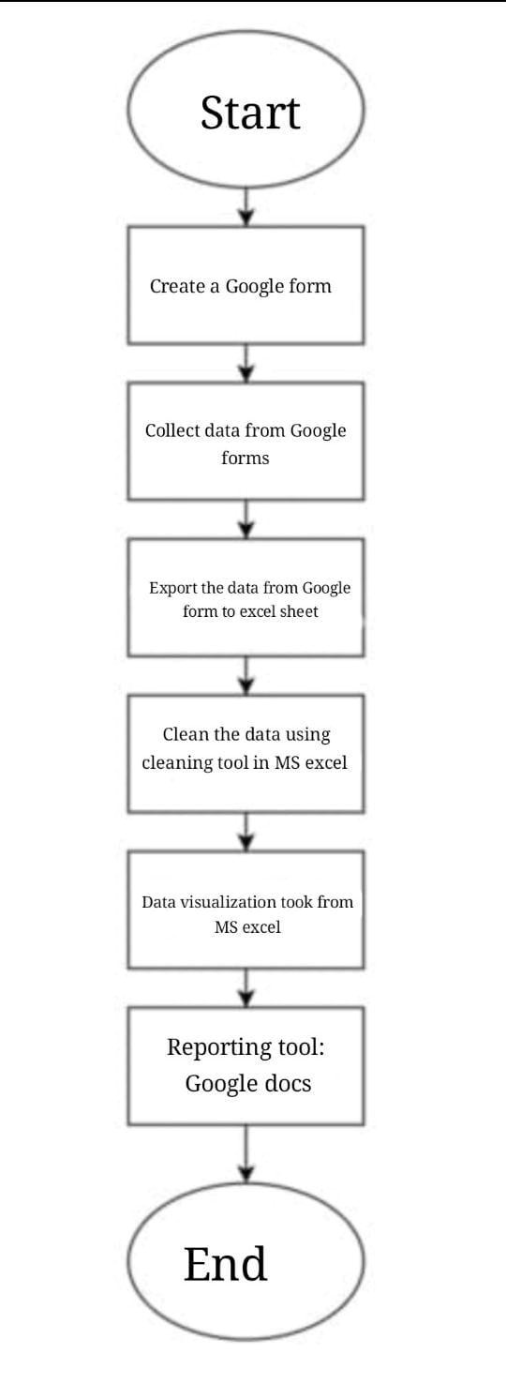

# CHAPTER 3 Data Analysis

## 3.1 Age

To analyze age data using a bar graph, we typically categorize ages into distinct groups (e.g., age ranges) and then count how many individuals fall into each group. This visualizes the frequency distribution of different age groups.

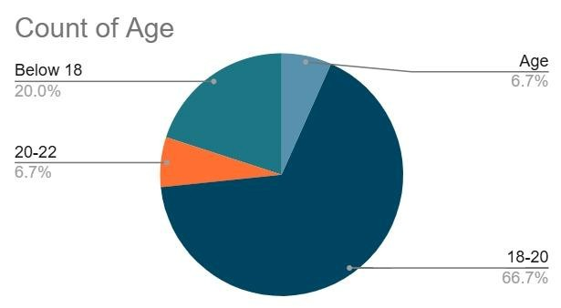

## 3.2 Bond between students and teacher’s

To analyze the bond between students and teachers using a bar graph, you can categorize the relationship into different levels or types of bonding (such as strong, moderate, or weak) and then count how many students report each level of bond with their teachers. This would give you a visual representation of how students perceive their relationship with teachers.

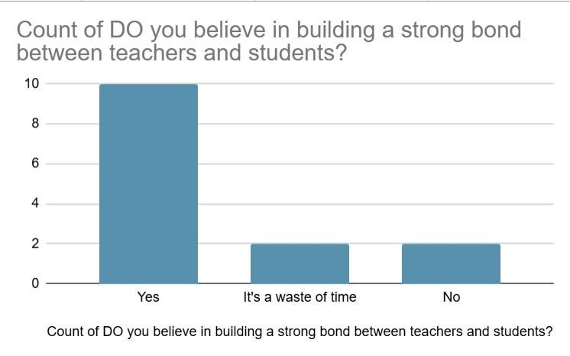

## 3.3 Approach to teachers

analyze the approach to teachers using a pie chart, we can examine how students interact with or approach their teachers. This might include factors like:

* Frequency of Approach: How often students approach teachers (e.g., "Often", "Sometimes", "Rarely").
* Reason for Approach: What the students approach teachers for (e.g., "Clarifying Doubts", "Asking for Help", "Social Interaction").
* Comfort Level: How comfortable students feel approaching their teachers (e.g., "Very Comfortable", "Somewhat Comfortable", "Uncomfortable").

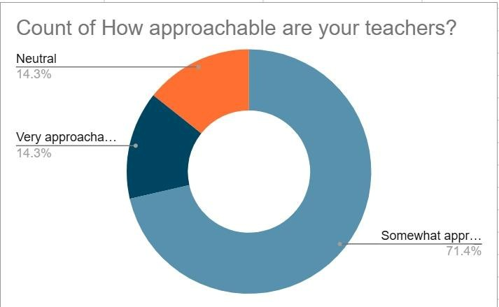

## 3.4 Communication

To analyze **communication between students and teachers** using a pie chart, we would need to categorize different communication methods or types of interactions and then visualize the proportion of students using each method. The types of communication can be related to how students communicate with teachers or how often they communicate.

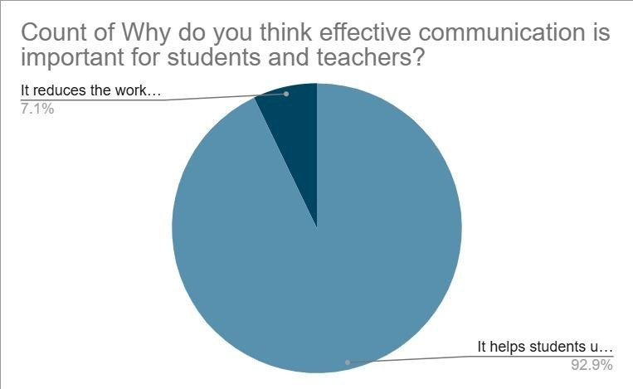

## 3.5 Comfort

To analyze the comfortability **of students with the teachers** using a pie chart, we would need to categorize how students feel about sharing their personal matters with the teachers and things that are apart from the academics.

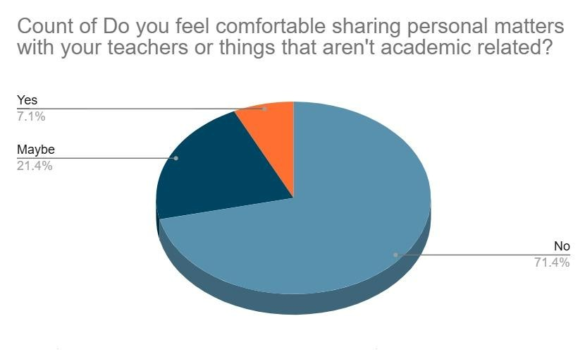

## 3.6 Accepting fault

This chart shows **how students accept their faults positively when the teacher yells** using a bar graph.

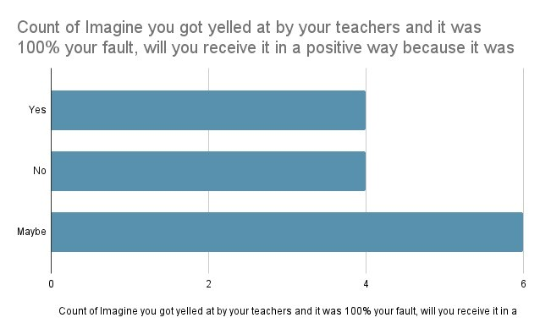

## 3.7 Encouragement

The chart visualizes responses to the question, "How well do your teachers encourage a positive classroom environment?" It depicts the frequency or average ratings of how students perceive their teachers' efforts in fostering a positive atmosphere. Each bar in the bar chart corresponds to a specific rating level, suggesting variation in student responses. Higher bars represent more positive ratings or higher agreement levels.

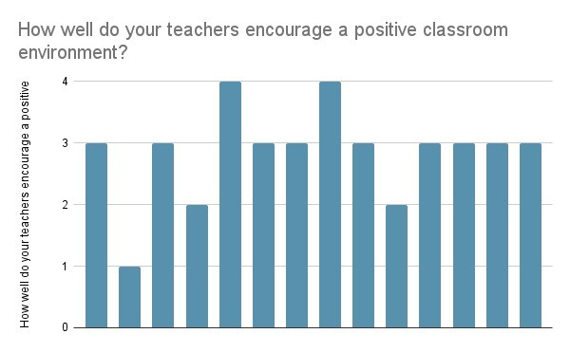

## 3.8 Expectations and instructions

a line chart might show that communication frequency peaks during exam periods or project deadlines, reflecting increased engagement during critical academic phases. Alternatively, it could reveal consistent upward or downward trends, indicating improved or declining communication efforts over time. Adding multiple lines to represent different communication methods or in-person meetings. This type of visualization highlights patterns, gaps, or areas of excellence in how teachers interact with students, offering actionable insights to enhance communication effectiveness and ensure students' needs are consistently met.

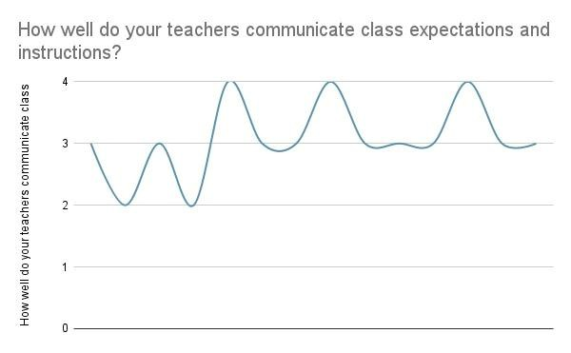

## 3.9 Environment of the class

A bar chart analyzing how well teachers encourage a positive environment can provide insights into various aspects, such as inclusivity, constructive feedback, motivation, and recognition of achievements. The chart might reveal that constructive feedback scores highest, highlighting its strong impact, while recognition of achievements scores lower, indicating an area for improvement. Such a visual comparison helps identify strengths and gaps, guiding teachers to balance their efforts and create a more inclusive and motivating classroom environment.

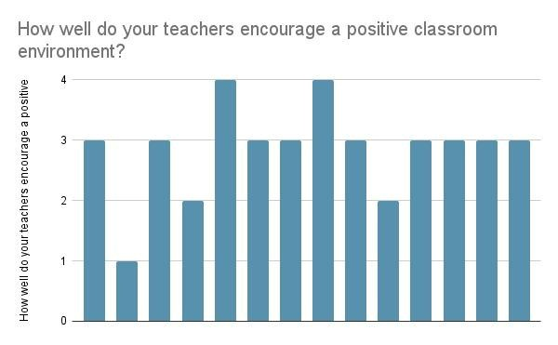

**3.10 Few of the responses we got according to the students of Jain Deemed to be University.**

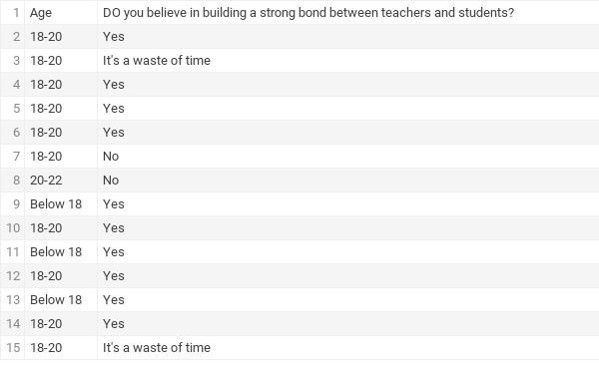

## 3.11 Bridging the Gap: Insights on Teacher-Student Engagement

This topic examines how students' responses to "Bridging the Gap: Insights on Teacher-Student Engagement" will likely focus on how they perceive their relationship with teachers, the level of interaction in class, and how it affects their learning experience. They might discuss how engaging teaching methods, open communication, and mutual respect contribute to a positive classroom environment. Responses could also highlight areas for improvement, such as more interactive lessons or better understanding between teachers and students. Ultimately, students will provide insights on what works well in their teacher-student interactions and suggest ways to strengthen that bond for a more effective and enjoyable learning experience.

The survey aimed to explore this theme through the following questions:

* Do your teachers make learning fun and engaging?
* Are you doing your part in being interactive with the teachers?
* How would you describe the quality of your relationship with your teachers?

The responses for these questions were summarized in a table using various formulas:

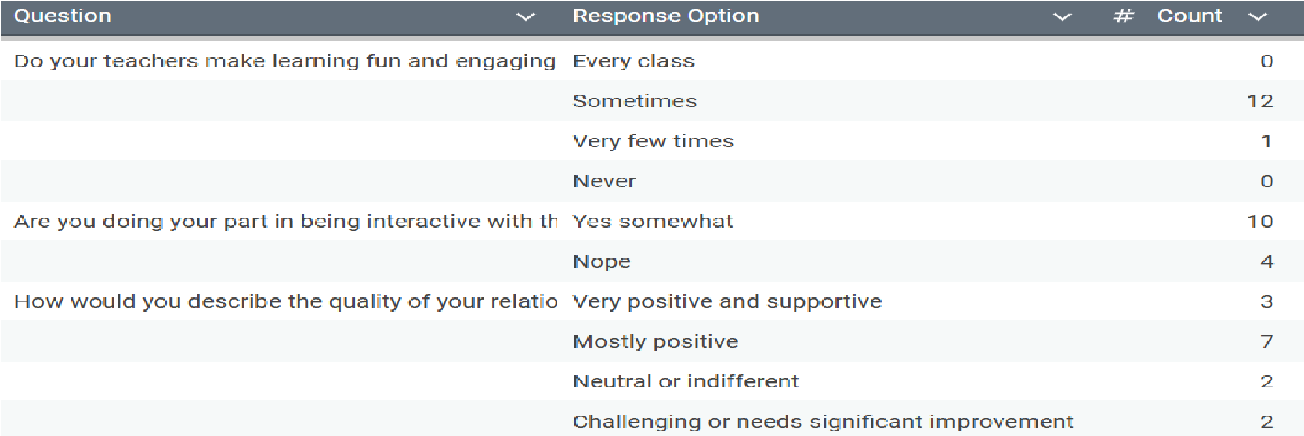

**3.12 Functions used :**

**3.12.1 SUMIF**

The SUMIF function sums the number of cells in a range that meet one condition.

**SYNTAX::**

=SUMIF(range, criteria, [sum_range])

The SUMIF function syntax has the following arguments: criteria_range (Required): The first range in which to evaluate the associated criteria. criteria1 (Required): The criteria in the form of a number, expression, cell reference, or text that define which cells will be summed up.

## 3.12.2 COUNTIFS

The **COUNTIFS** function applies criteria to cells across multiple ranges and counts the number of times all criteria are met **Syntax:**

COUNTIFS(criteria_range1, criteria1, [criteria_range2, criteria2]…) The COUNTIFS function syntax has the following arguments: criteria_range1 (Required): The first range in which to evaluate the associated criteria. criteria1 (Required): The criteria in the form of a number, expression, cell reference, or text that define which cells will be counted.

For example, criteria can be expressed as 32, ">32", B4, "apples", or "32". criteria_range2, criteria2, ... (Optional): Additional ranges and their associated criteria. Up to 127 range/criteria pairs are allowed. [1]

## 3.12.3 VLOOKUP

The **VLOOKUP** function in Excel is used to find information in a table or range by row. It works by searching down the first column of a table to find a match, and then retrieving data from the specified column of the same row

**Syntax:**

=VLOOKUP(lookup_value, table_array, col_index_num,

[range_lookup])

In its simplest form, the VLOOKUP function says: =VLOOKUP(What you want to look up, where you want to look for it, the column number in the range containing the value to return, return an Approximate or Exact match – indicated as 1/TRUE, or 0/FALSE).

# CHAPTER 4 Inference and Key Insights

**4.1 The Impact of Student-Teacher Relationships on Academic**

## Aspirations

The relationship between students and teachers plays a crucial role in shaping students’ academic aspirations. Supportive and approachable teachers inspire students to value further education by fostering motivation, curiosity, and confidence. By offering guidance, sharing experiences, and connecting studies to real-world applications, teachers can help students see the benefits of advanced learning.

A positive student-teacher dynamic encourages open communication and mentorship, empowering students to pursue higher education with clarity and confidence, ultimately fostering a culture of continuous growth.

### 4.2 Insights

This analysis underscores the importance of the relationship between students and teachers in shaping academic and career priorities. While teachers play a crucial role in guiding students, a lack of effective communication or personalized mentorship can hinder students’ ability to develop a clear and structured approach to their goals.

In some cases, rigid teaching styles or insufficient awareness of industry trends might leave students feeling disconnected from real-world applications of their education. Such gaps in support may lead to uncertainty in balancing further education with career alignment. Addressing these challenges requires fostering a more adaptive and student-focused approach to ensure all students receive the guidance needed to navigate their academic and professional journeys effectively.

**4.3 The Role of Communication between the Student-Teacher**

## Relationship



### 4.4 Understanding the Graph: Teacher Communication and Student Perception

This graph illustrates student perceptions of how effectively teachers communicate class expectations and instructions. This communication is a cornerstone of a healthy student-teacher relationship, impacting learning, student comfort, and overall classroom dynamics.

### 4.5 Interpreting the Axes and Scales

● Y-axis (Vertical): Rating Scale: The vertical axis represents the students' ratings of teacher communication effectiveness. The scale ranges from 0 to 4.

○ 4: Likely signifies the highest rating, indicating "Excellent" or "Very Effective" communication.

○ 0: Likely signifies the lowest rating, indicating "Very Poor" or "Ineffective" communication.

○ Values in between (1, 2, and 3) represent varying degrees of communication effectiveness

This graph shows that teacher communication with students isn't always consistent. Sometimes it's great, but other times it's not as clear. Because clear communication is key to a good student-teacher relationship and helps students learn better, teachers and schools should focus on making sure instructions and expectations are clear *all the time*, not just some of the time. This will help students succeed.

### 4.6 Insights

The graph shows inconsistent teacher communication. Even good moments don't make up for the bad ones, which negatively affect students. This inconsistency comes from many factors, but the graph helps schools and teachers improve by focusing on clear and consistent communication, based on student feedback. How students understand is key.

Students highly connect with the subject when they connect with or find the teacher friendly, communicative and likeable. Subjects that are taken by teachers who bore the students or give extensive workload to the students are often seen as a burden or as a snare to most of the students who majorly associate a particular subject with its specific teacher.

**Chapter 5**

# Conclusion

This study provides valuable insights into the factors influencing students' education, emphasizing the role of teachers, teaching skill, communication levels, and open-minded attitude. The findings reveal distinct student-teacher trends, with students showing greater receptiveness to external influences and a stronger inclination toward interest and a new sense of exploration in that subject. As teachers exhibit more communication , more efficient teaching styles and a willingness to explore student thought processes. Student teacher relationships emerge as a critical factor in building confidence with students. A positive relationship can increase academic engagement and reduce academic pressure. Students with a strong relationship with their teacher feel safe to ask for help and are more likely to accept academic challenges. Teachers can serve as role models and mentors, helping students develop life skills, values, and a passion for learning. Teachers can serve as role models and mentors, helping students develop life skills, values, and a passion for learning.Teachers can serve as role models and mentors, helping students develop life skills, values, and a passion for learning.

## References

1. Microsoft Support. Retrieved November 25, 2024, from

https://support.microsoft.com/en-us/office/unique-function-c5ab87 fd-30a3- 4ce9-9d1a-40204fb85e1e [4] Microsoft. (n.d.). Available chart types in Office.

1. Microsoft Support. Retrieved November 25, 2024, from

https://support.microsoft.com/en-us/office/available-charttypes-inoffice-a6187218-807e-4103-9e0a-27cdb19afb90